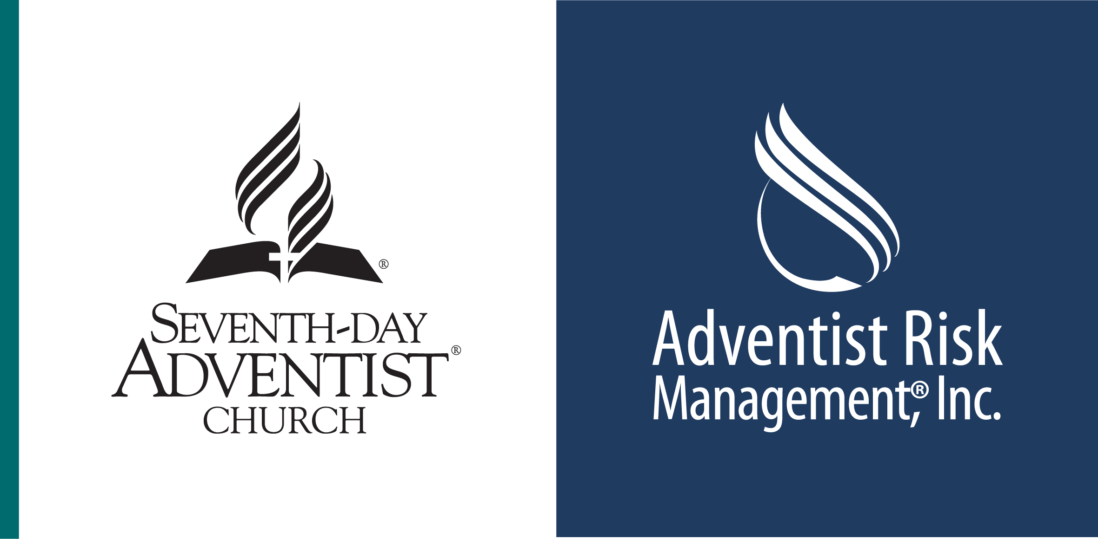
Continuation of Employee Benefits

For the Retiring or Terminating Employee

Name ─────────────────────── Date ─────────

Employer ─────────────────────

It is possible that the employee benefits under which you have been covered while employed may be continued on a direct bill basis. Options to continue coverage include porting and/or conversion. Porting or conversion allows you to maintain coverage without having to provide medical evidence of insurability. In order to port or convert coverage, you must submit a written request to VOYA (ReliaStar Life) within 31 days of your retirement/termination date.

▪ Porting (supplemental Life only) – to continue like coverage at a group rate. ($500,000 maximum) Employees and dependents who have reached age 70 are not eligible for portability.
▪ Conversion (Basic Group Life) – to continue like coverage at an individual rate. Subject to a minimum of $10,000.

- EMPLOYER PROVIDED INSURANCE (Previously paid by your employer in full)

▪ VOYA Basic Group Life – ReliaStar Life (Policy #: 67807-4)

Coverage: $100,000/employee $50,000/spouse $10,000/dependent

To Convert your basic life coverage: Complete the conversion form, keep a copy and submit directly to VOYA Employee Benefits (ReliaStar Life Insurance Company) with your first quarter premium.

▪ NAD Health Care Assistance Plan

Your health care coverage under the NAD Health Care Assistance Plan terminates on your last day of employment. The Plan does not allow for porting coverage. If you are retiring, please speak with someone in the Retirement Office or your Human Resources Department to secure paperwork for Medicare benefits.

- VOLUNTARY INSURANCE ( Previously employee paid via payroll deductions)

▪ VOYA Supplemental Life – ReliaStar Life (Policy #: 67807-4)

Coverage: $_________/employee $_________/spouse $_________dependent(s)
Premium: $__________

To Port your Supplemental Life coverage: Complete form, keep a copy and submit directly to VOYA Employee Benefits (ReliaStar Life Insurance Company). You will receive a quarterly invoice mailed directly to your home.

Porting Limitations: Your amount in force just prior to leaving employment but not to exceed $500,000 with a minimum of $10,000.

*Retiree Continuation of Supplemental Life: Continuation of any Supplemental Life insurance in force prior to retirement is available. The rates are the same as when you were an active employee. Complete form and submit directly to Selman Group (address on application). Please do not include premium. Selman will invoice the Retiree. *Retirees are not eligible to port Supplemental Life coverage.

▪ VOYA – AD&D (Accidental Death & Dismemberment) Conversion privilege discontinued effective 1/1/13.

▪ AFLAC

Short Term Disability Coverage $________ Premium $________
Accident Coverage $________ Premium $________
Hospital Coverage $________ Premium $________
Cancer Coverage $________ Premium $________
Intensive Care Coverage $________ Premium $________
Porting Information: Contact AFLAC at 1.800.99.AFLAC
Conversion Information: Contact AFLAC at 1.800.99.AFLAC

