Benefits

Open Enrollment 2021

ACTION NEEDED

NOTE: Content in red to be updated by employers with specifics for their organization

Open Enrollment – employee newsletter or email message

It's time to elect your 2021 healthcare and other benefits during our Open Enrollment period, [INSERT dates must be after September 28 and before October 30, and no less than 2 weeks during these dates]

Open enrollment gives you the opportunity to make your healthcare plan election, as well as view Primary (employer paid) and enroll in Voluntary (employee paid) benefits based on your eligibility.

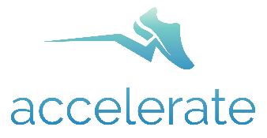
The Accelerate Healthcare Plan offers the best benefits at the best value in exchange for your engagement and accountability for your health and wellness. This plan encourages active participation, plus incorporates popular lifestyle programs such as CHIP and Weight Watchers.

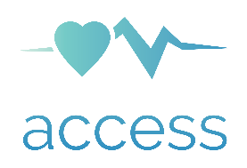
The Access Healthcare Plan provides market-competitive, quality benefits. The Access Plan does not require your participation in the activity-based lifestyle and wellness program and has higher financial responsibility for members.

Primary and Voluntary
As part of the open enrollment process you will be able to select available benefits such as life, and other insurances.
You must take action!
[INSERT if your organization uses an enrollment system other than bswift enter those directions here and edit below as needed]

Benefit elections can be made by going to:
AscendtoWholeness.org then click the Benefits Management button (top right). Then select the appropriate option in the popup window.
Go online and learn more!

Visit the website at www.AscendtoWholeness.org for more information, answers to frequently asked questions, and details on how to enroll for 2021 benefits.
Human Resources Contact [INSERT contact information]
Check your [email or mailbox] for your Open Enrollment packet containing more information!

